MARKING SCHEME
MATHEMATICS PAPER 121/1
ARISE AND SHINEFORM 4TRIAL 2 EXAMINATION
JULY – 2026

1  2  3.  4  5  6  7  8  9.  10  11  12  13  14.  15  16  17  18.  19(a)  (b) (i)  (ii)  20  (a)  (b)  (c)  (d)  21(a)  (b)  (c)  (d)  22(a)  (b)  23.  24. (a)(i)  (ii)  (b)  c) | .$\frac{1}{25} x \frac{100}{5}→ \frac{4}{5}$  4 x 6 = 24  24 +$\frac{4}{5}+\frac{1}{5}$ =$\frac{24+5}{5}$  =25  .$\frac{-3}{-6}= \frac{1}{2}$  6 of 3 = 18  .$\frac{1}{2}+ 23-18=5.5$  24 x $\frac{2}{11 }$= $\frac{50}{11}$  = 4 $\frac{6}{11}$  2 x 2 x 3 M₁  GCD = 12 A₁  Boys $\frac{120}{12}=10 boys$  Girls $\frac{180}{12}$ = 15 girls B₁  Teacher $\frac{24}{12}$= 2 teachers  ,$\frac{{4x}^{2-1}}{x^{2-1}}$ $⇒ \frac{\left(2x-1\right)\left(2x+1\right)}{\left(x-1\right)\left(x+1\right)}$  . $\frac{\left(2x-1\right)\left(2x+1\right)}{\left(x-1\right)\left(x+1\right)}$ x $\frac{\left(x-1\right)}{\left(2x+1\right)}$  ; $\frac{2x-1}{x+1}$  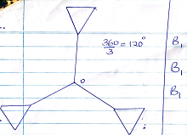  20,000 x 147.56 - 2510 200  = Ksh 441 000  US Dollar $\frac{441 000}{74.50}$  US Dollar 5,919.46  M₁ for 5y = 2x – 3  is ²/₅  M₂ = ⁻⁵/₂  .$\frac{y+2}{x-5}$ = ⁻⁵/₂  2y+4=-5x+25  2y+5x+4-25= 0  2y+5x-21= 0  (2x + 30) + x = 90  3x = 60  x = 20  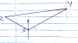  8.15 am 63km/h met at 10.45am  9.00 am  Dist in 45 min  R.d = $\frac{45}{60}$x 63  = 47.25km  Time to meet$⇒$ 1 lhr 45 min  R.S x - 63  x - 3 = $\frac{47.25}{1\frac{3}{4}}$  x = 27 + 63  = 90km/h  ‘$\frac{dy}{dx}$ = 3x² – 12x + 96  P(1,4)  Grad when x = 1  G = 3(1)  = 6  ,$\frac{y-4 }{x-1}$= 6  y = 6x – 6 + 4  y = 6x – 2  V.s.f = $\frac{12500}{800}$ $⇒\frac{125}{8}$  Lsf = 5:2  Asf = 25:4  .$\frac{25}{4}$ = $\frac{x}{216}$  x = $\frac{216 x 25}{4}$  = 1350cm²  7x x  7x + x = 180  x = 22.5  n = $\frac{180}{22.5}$  = 16 sides  1 + $\frac{1}{2}x≤$ 2x – 3  4 $≤$ 1.5x  .$\frac{4}{1.5} ≤x$  . $2\frac{2}{3} ≤x$  2x – 3 < x +  x < 5  2 ²/₃ $≤$ x < 5  integral values 3,4  5^{2x} – 5^{2x}.5⁻¹ = 500  Let 5^{2x} be y  y - $\frac{y}{5}$ = 500  5y – y = 2500  4y = 2500  y = 625  5^{2x} = 625  5^{2x} = 5⁴  2x = 4  x = 2  k$\left(\begin{matrix}-4 \\ 6\end{matrix}\right)$ - $\left(\begin{matrix}2 \\ a\end{matrix}\right)$ = k $\left(\begin{matrix}-6 \\ 6-a\end{matrix}\right)$ = $\left(\begin{matrix}-8 \\ 2\end{matrix}\right)$  k =$\frac{-8}{-6}$ $⇒$ $\frac{-4}{+3}$  $\frac{ 4}{3}$ $\left(6-a\right)$= 2  $$24-4a=6$$  -4a = 6 – 24  a = $\frac{-18}{-4}$  a = 4.5  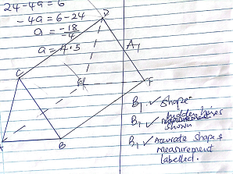  (c) (i). (3.2x50) + (2.4x50) + 3.8 $×$ x=500$√$  3.8x = 220  x = 57.895  $∴$ median = 200 + 57.895  $$ksh=257.90√$$  (ii) 160 + 120 + 380 + 240 + (50x0.5)$√$M₁  925$√$ A₁  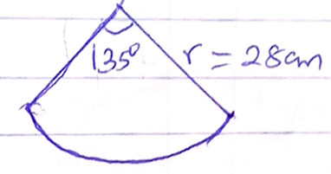  1c = 57.29º  ? = 135º  = 2.356^{c} radius  Area = ¹/₂${θ^{c}}^{r^{2}}$  = ½ x 2.356 x 28²  = 923.65cm²  (ii) L = $θ^{c}r$  = 2.356x28$√$  = 66cm  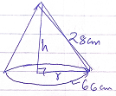  2$π$r = 66  22 x ²²/₇ x r = 66  =10.5cm  ¹/₃$π$r²h  h = $\sqrt{{28}^{2}-{10.5}^{2}}$  = 25.96cm  ¹/₃ x ²²/₇ x 10.5² x 25.96  = 2998.38cm³  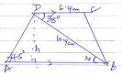  BC² = 10.9² + 6.4² – 2 x 10.9 x 6.4 cos 38º  = 49.83  BC = 7.059  = 7.1cm  $∠$ADB = 180 – (38+45º) = 97º  $$\frac{AB}{sin97}=\frac{10.9}{\sin{45}}$$  AB = 15.3  Sin 38 = $\frac{h}{10.9}$  h = 6.7cm  ,$\frac{7.1}{\sin{38}}$ = 2R  R = 5.766  = 5.8cm  A$≈$h (y₁+y₂+---+y_{n})  h = $\frac{-3- -6}{6}$ = 0.5  A = 0.5(18.56+14.06+10.06+6.56+3.56+1.06)  = 26.93 sq.units  .$\int_{-6}^{-3}{x^{2}}$ + 2x -3 dx  .$\frac{x^{3}}{3}$ + x² – 3x -3  -6  .$\left(\frac{{\left(-3\right)}^{3}}{3}+ {\left(-3\right)}^{2}-3(-3)\right)$  .$\left(\frac{{\left(-6\right)}^{3}}{3}+ {\left(-6\right)}^{2}-3(-6)\right)$  9 – (18) = 27 square unit  $\frac{27-26.93 }{27}$ x 100  $\frac{0.07}{27}$ x 100  $$=0.2593\%$$  AB = $\left(\begin{matrix}3 & x \\ x+1 & 2\end{matrix}\right)\left(\begin{matrix}1 & 2 \\ 3 & 0\end{matrix}\right)$  = $\left(\begin{matrix}3+3x & 6 \\ x+1+6 & 2x+2\end{matrix}\right)$  =$\left(\begin{matrix}3x+3 & 6 \\ x+7 & 2x+2\end{matrix}\right)$  Det  (3x+3)(2x+2) – 6(x+7) = 0  6x² + 6x + 6x + 6 – 6x – 42 = 0  6x² + 6x – 36 = 0  x² + x – 6 = 0  x² – 2x + 3x – 6 = 0  x(x-2) + 3(x-2) = 0  (x-2) (x+3) = 0  x = 2 or x = -3  3x + 5y = 165  - 2x + 4y = 120  - $\left(\begin{matrix}3 & 5 \\ 2 & 4\end{matrix}\right)\left(\begin{matrix}x \\ y\end{matrix}\right)\left(\begin{matrix}165 \\ 120\end{matrix}\right)$  Det = 12 – 10 = 2 ine ½ $\left(\begin{matrix}4 & -5 \\ -2 & 3\end{matrix}\right)$  ½ $\left(\begin{matrix}4 & -5 \\ -2 & 3\end{matrix}\right)\left(\begin{matrix}3 & 5 \\ 2 & 4\end{matrix}\right)\left(\begin{matrix}x \\ y\end{matrix}\right)$ = ½ $\left(\begin{matrix}4 & -5 \\ -2 & 3\end{matrix}\right)\left(\begin{matrix}165 \\ 120\end{matrix}\right)$  $\left(\begin{matrix}x \\ y\end{matrix}\right)$ = ½ $\left(\begin{matrix}60 \\ 30\end{matrix}\right)$  $$\left(\begin{matrix}x \\ y\end{matrix}\right)\left(\begin{matrix}30 \\ 15\end{matrix}\right)$$  x = 30 and y = 15  - Cost per student  2(30) + 1(15) = 75  Cost = 36 x 75  = 2700/=  y = (x²+1) (x-2)  x – intercept; y =0  (x²+1) (x-2) = 0  x²+1 = 0 x= $\sqrt{1}$  x – 2 = 0 x = 2  y – x intercept  x = 0  y = -2  y = x3 – 2x2 + x – 2  - At stationary point ^{dy}/_{dx} = 0  ^{dy}/_{dx} = 3x² – 4x +1  3x² – 4x + 1 = 0  3x² – 3x – x + 1 = 0  3x(x-1) -1(x-1) = 0  (3x – 1) (x – 1) = 0  x = ¹/₃ or x = 1  when x = 1, y = -2 (1,⁻2)  x = ¹/₃ y = ⁻⁵⁰/₂₇  ( ½ , 1 ²³/₂₇)  (ii)$\frac{{dy}^{2}}{{dx}^{2}}$ = 6x -4  at (1,2) , $\frac{d^{2}y}{{dx}^{2}}$ = 6 – 4 = 2  (1,-2) minimum point  $\left(\frac{1}{3},1 \frac{23}{27}\right)$ $→$ $\frac{d^{2}y}{{dx}^{2}}$ = -2  hence maximum point  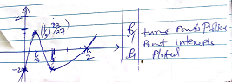 | M₁  M₁ -Accept 5 ½  M₁ –process of getting GCD  A₁ for 12  B₁ for number of each steering committee  M₁  M₁  A₁  B₁ Seen or measure  B₁ $√$any one correct  B₁ $√$Ccomplete pattern  M₁ conversion  M₁  A₁  B1  M1  A1  M₁  A₁  B₁$√$ location of y  B₁$√$ location of z  B₁ $√$Joining relative positions of xyz  M₁  M₁  A₁  M₁  A₁  B₁  M₁  A₁  M₁  M₁  A₁  B1  B₁  B₁  M₁  M1  A1  M1  M1  A1  B₁ $√$shape  B₁$√$ hidden lines shown  B₁ $√$Accurate shape and measurement labelled.  A₁ NB money rounded off to nearest cents  M1  A1  B1  M1  A1  M1  A1  M1  A1  M1  M1  A1  M1  A1  B1  M1  A1  M1  A1  M1  A1  $√$B1 $√$all value  B1M1$√ordinates$  A1  M1 integration  M1 substitute  A1  M1  A1  M1  M1  A1  B1 both eans  M1-inverse  M1  A1 boths  M1  A1  M1  - undefnea  A1  B1  M1  A1  B1  B1  B1  B1 turns points plotted point intercepts  B1 plotted
  2  2  3  $$√$$ | 120  60  30  10 | 180  90  45  15 | 24  12  6  2
  x | -6 | -5.75 | -5.5 | -5.25 | -5 | -4.75
  y | 21 | 18.56 | 16.25 | 14.06 | 12 | 10.06
  x | -4.5 | -4.25 | -4.0 | -3.75 | 3.5
  y | 8.25 | 6.6 | 5 | 3.56 | 2.25
  x | -3.25 | -3
  y | 1.06 | 0

No.17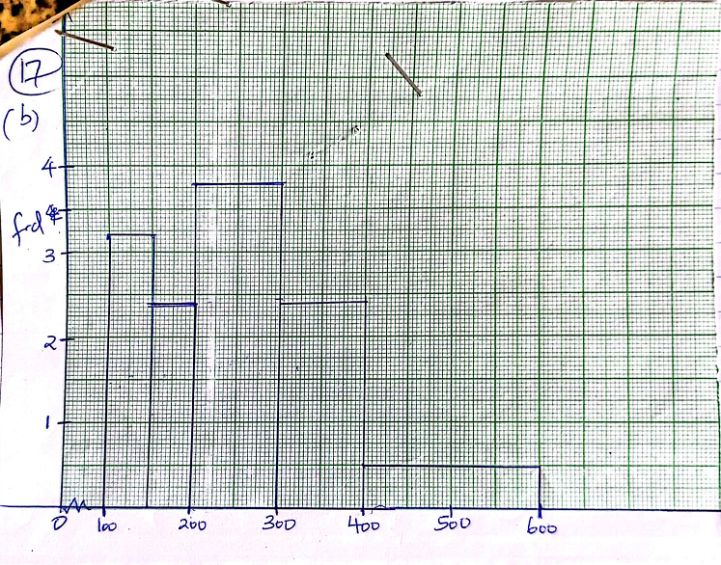
No.18
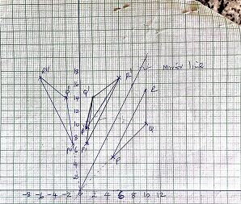
Q.no.23.
